**Executive Summary**:

The Data gathered from Montreal Police central intelligence database was analysed to conduct social network analysis on identified gangs, allegiances, and territorial control. Key Social Network Analysis (SNA) factors were examined that identified Afro-Canadian gang ethnicity to have the highest influence and was the most central amongst other gang ethnicities. Amongst the two gang affiliations, Bloods and Crips, Crips was identified to be the more influential one regarding its centrality. The territory data which included Downtown, East, and West, identified East to have the highest betweeness, closeness, and eigenvector, but West to score much higher on degree.

**Introduction/Background**:

Data obtained from Montreal Police central database, which was used to reconstruct organization of drug distribution operations in Montreal, was imported into Analyst Notebook (figure 1.0) to analyse the most connected entities and conduct social network analysis for relationships between gangs which included: Gang Affiliation, Gang Ethnicity, and Territory data. The social network analysis factors of centrality which included betweeness, closeness, degree, and eigenvector centrality were calculated through Analyst Notebook and the results were then put in a table in an Excel sheet (figure 2.0). Amongst the gang ethnicities, Afro Canadians were identified to be the most central. They had the highest betweeness, closeness, degree, and eigenvector centrality, when compared to other gang ethnicities. This means that Afro Canadians are the most important when it comes to the gang connections/ties, influence in being the bridge in gang networks, and can easily distribute drugs or information to others. Amongst the Gang Affiliations, Crips was identified to be the most central one. This means that Crips were more influential than Bloods to have the control of gang networks and connections. The territory which was the most central was the East, with highest betweeness, closeness, and eigenvector.

**Recommendation**:

Based on the results gathered from doing a social network analysis through Analyst Notebook, it would be helpful to focus Policing resources and target Gang ethnicities which are Afro Canadians, belong to the Crips gang affiliation, and are mostly spread across East and West Montreal territory.

Figure 1.0

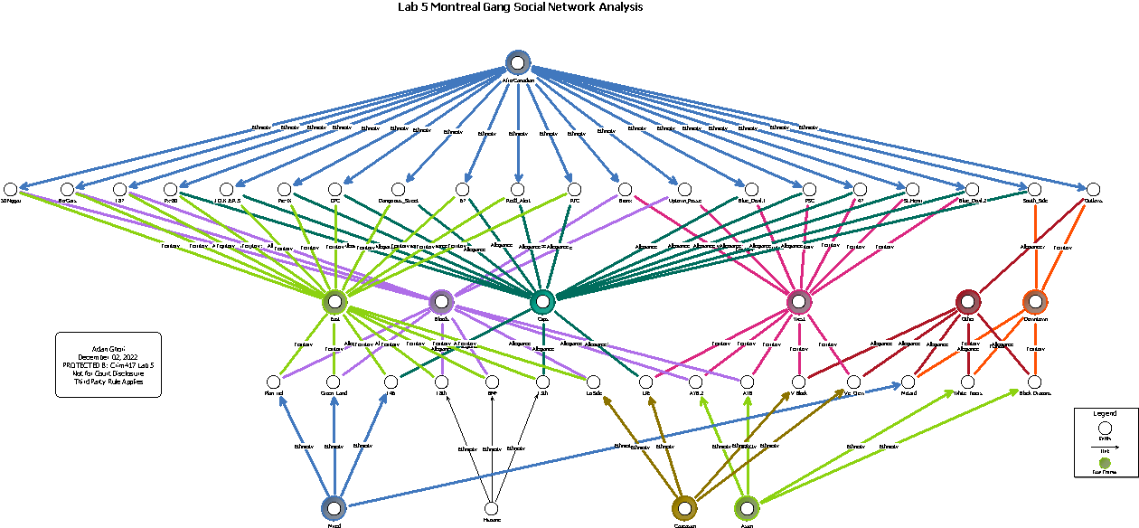Figure 2.0

|  |  |  |  |  |
| --- | --- | --- | --- | --- |
| **Entity** | **Betweenness%** | **Closeness%** | **Degree%** | **Eigenvector%** |
| 13th | 2.241 | 37.815 | 6.667 | 15.674 |
| 146 | 2.401 | 39.13 | 6.667 | 15.723 |
| 187 | 1.128 | 42.056 | 6.667 | 19.625 |
| 18th | 1.494 | 36 | 6.667 | 11.686 |
| 47 | 1.127 | 40.541 | 6.667 | 19.965 |
| 50 Niggaz | 1.128 | 42.056 | 6.667 | 19.625 |
| 67 | 0.658 | 40.541 | 6.667 | 23.613 |
| Afro-Canadian | 26.009 | 48.387 | 44.444 | 59.757 |
| Asian | 3.001 | 30.201 | 8.889 | 2.716 |
| AYB | 3.318 | 37.19 | 6.667 | 7.594 |
| AYB.2 | 3.318 | 37.19 | 6.667 | 7.594 |
| Black_Dragons | 0.86 | 29.801 | 6.667 | 1.647 |
| Bloods | 14.464 | 42.056 | 26.667 | 24.164 |
| Blue_Devil.1 | 1.127 | 40.541 | 6.667 | 19.965 |
| Blue_Devil.2 | 1.127 | 40.541 | 6.667 | 19.965 |
| BMF | 1.494 | 36 | 6.667 | 11.686 |
| Bo-Gars | 1.128 | 42.056 | 6.667 | 19.625 |
| Bronx | 1.645 | 42.857 | 6.667 | 15.977 |
| Caucasian | 2.107 | 35.433 | 8.889 | 4.891 |
| Crips | 17.665 | 46.392 | 37.778 | 51.298 |
| Dangerous_Street | 0.658 | 40.541 | 6.667 | 23.613 |
| Downtown | 5.167 | 34.351 | 11.111 | 4.775 |
| DPC | 0.658 | 40.541 | 6.667 | 23.613 |
| East | 20.241 | 44.554 | 40 | 49.612 |
| Green_Land | 1.754 | 37.815 | 6.667 | 11.735 |
| Hispanic | 0.277 | 30.612 | 6.667 | 5.738 |
| J.O.K.E.R.S | 0.658 | 40.541 | 6.667 | 23.613 |
| Lg Side | 2.939 | 38.462 | 6.667 | 11.561 |
| LPE | 2.021 | 38.462 | 6.667 | 11.901 |
| Mixed | 3.233 | 35.433 | 8.889 | 6.075 |
| Motard | 2.161 | 30.612 | 6.667 | 2.141 |
| Other | 5.385 | 34.884 | 13.333 | 3.715 |
| Outlaws | 5.246 | 38.462 | 6.667 | 10.03 |
| Pie-IX | 0.658 | 40.541 | 6.667 | 23.613 |
| Plan_riel | 1.754 | 37.815 | 6.667 | 11.735 |
| PSC | 1.127 | 40.541 | 6.667 | 19.965 |
| Px-80 | 0.658 | 40.541 | 6.667 | 23.613 |
| Redd_Alert | 0.658 | 40.541 | 6.667 | 23.613 |
| RTC | 0.658 | 40.541 | 6.667 | 23.613 |
| South_Side | 4.593 | 39.823 | 6.667 | 17.023 |
| St.Henri | 1.127 | 40.541 | 6.667 | 19.965 |
| Uptown_Posse | 1.645 | 42.857 | 6.667 | 15.977 |
| V_Block | 1.824 | 33.835 | 6.667 | 4.908 |
| Ve_Crew | 1.824 | 33.835 | 6.667 | 4.908 |
| West | 14.674 | 41.284 | 26.667 | 24.791 |
| White_Tigers | 0.86 | 29.801 | 6.667 | 1.647 |

Report Completed and submitted – December 06, 2022

Adan Ghori

Crim 417 Intelligence Analysis Course

Exercise Lab 5

For Investigative Purposes Only

Third Party Rule Applies